Raj Patel
Assignment I

1.3 [2] <§1.3> Describe the steps that transform a program written in a high-level language such as C into a representation that is directly executed by a computer processor.

A program written in a high-level language goes through the compiler to be compiled into the Assembly language then through the assembler to be assembled and then through the linker in order to link all the external files and libraries. Finally, it gets processed in the computer. Sometimes the program will skip the assembler and go directly from compiler to linker and if it is an Assembly language program then it would skip compilation and go directly through the assembler.

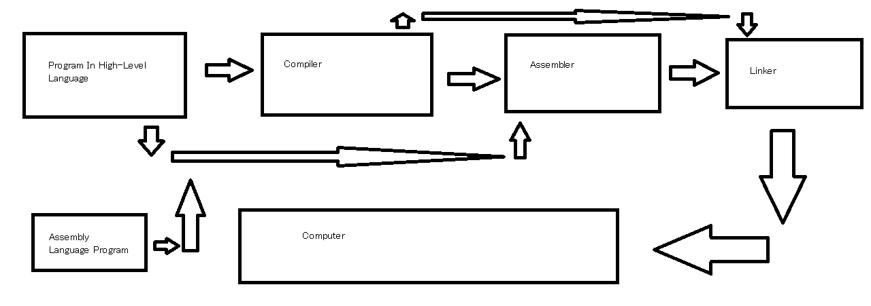
A.6 – Summation.asm

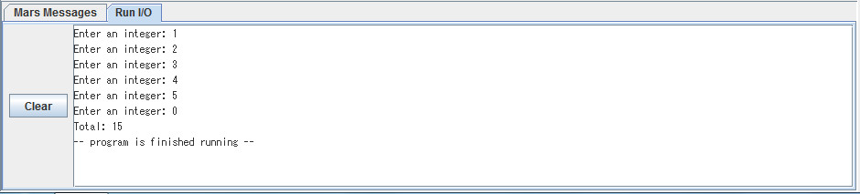

A.7 – LargeSummation.asm
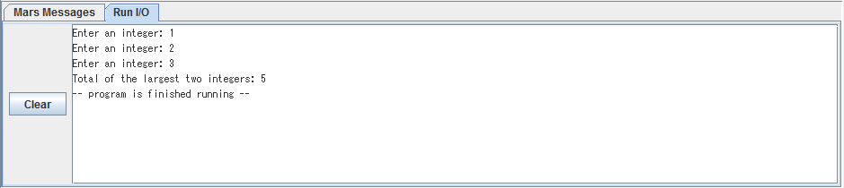

A.8 – IntToName.asm
